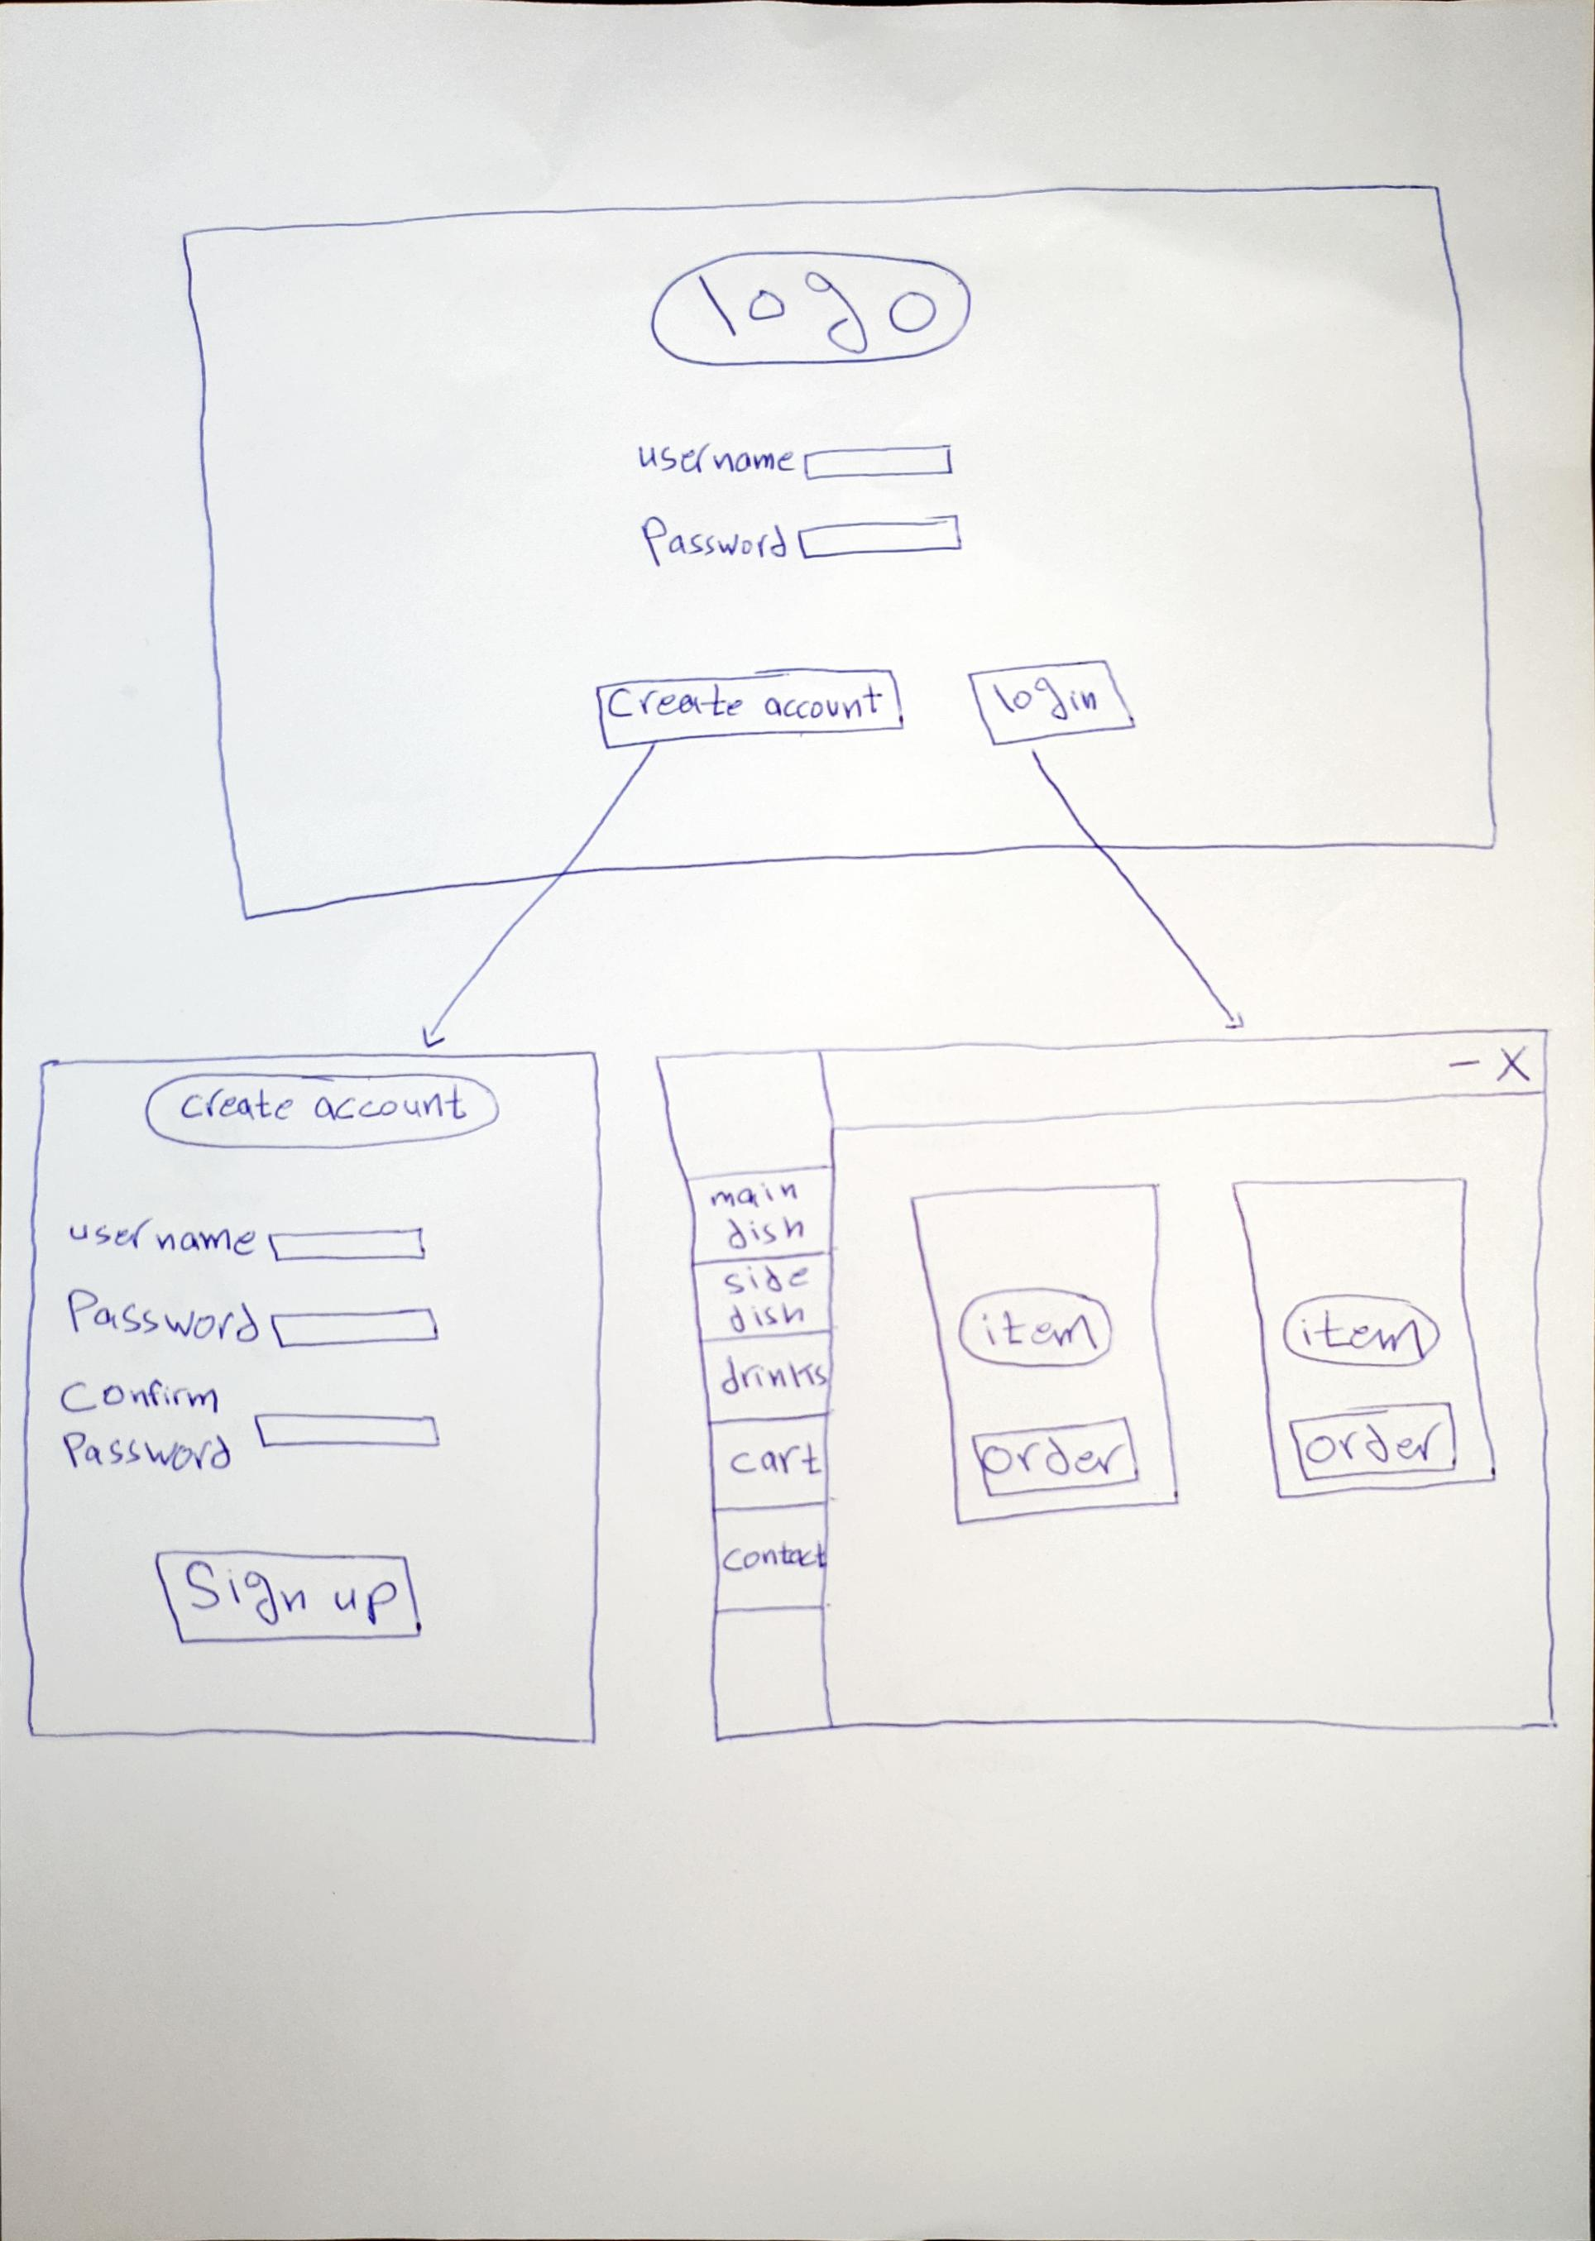 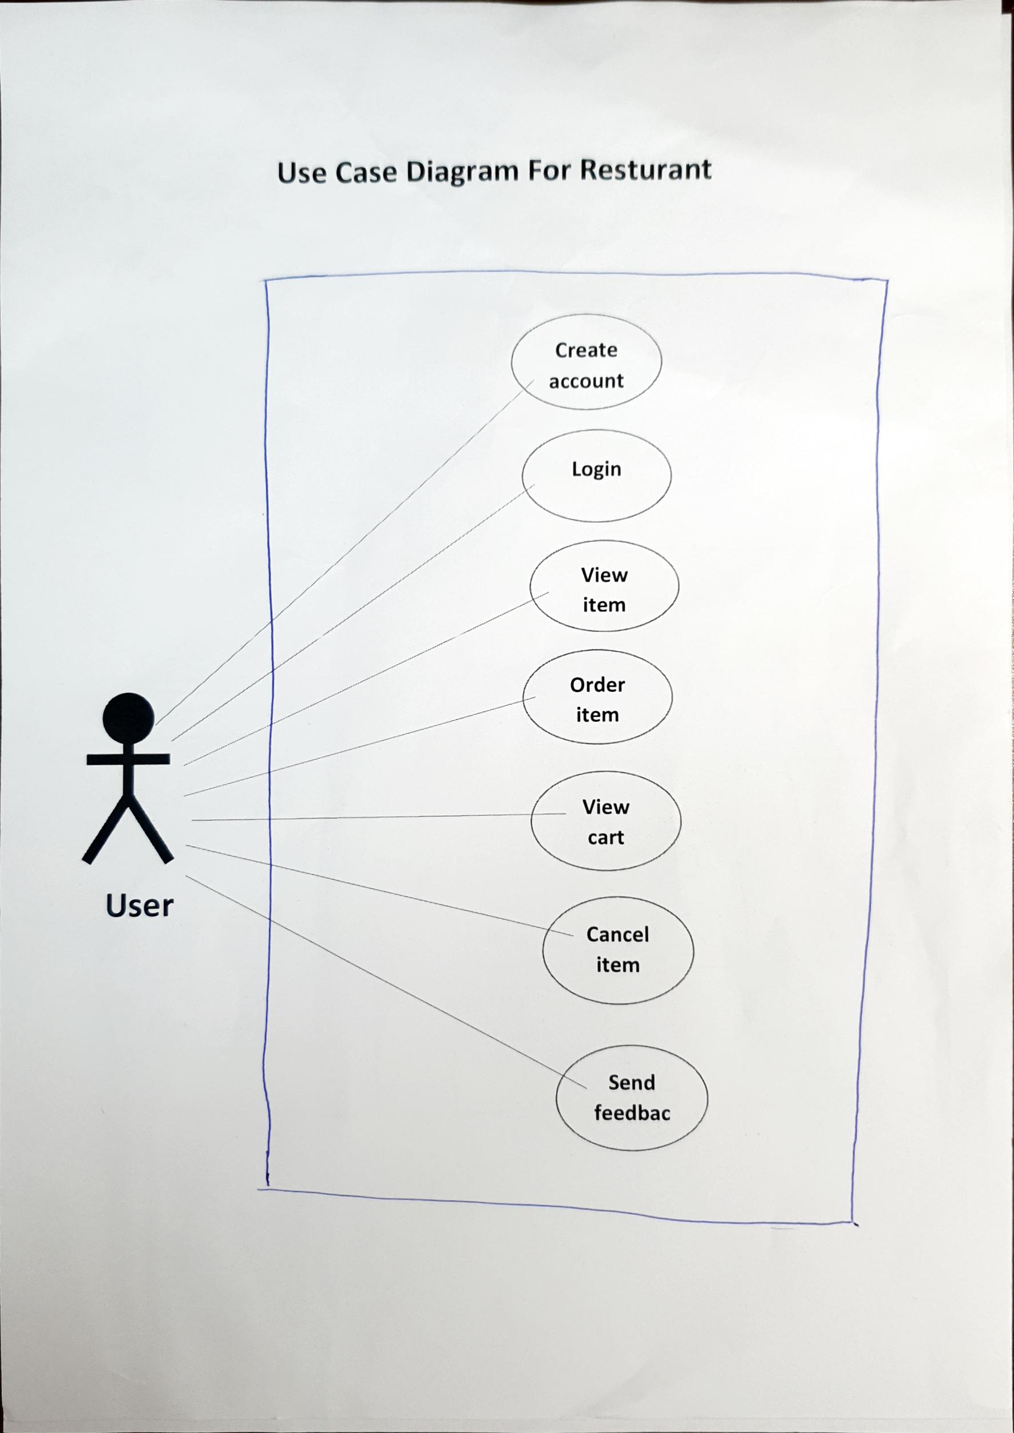 email logo

 contact us logo

 drink menu logo

 fax logo

 cart logo

side dish logo

min dish logo

phone number logo

 minimise logo

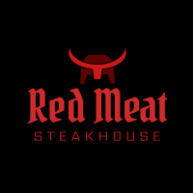 main logo